Image Processing

*Face Detection Project*

Lilit Harutyunyan

December 7, 2019

*Images assigned to me are 47_xx.jpg, 48_xx.jpg, 49_xx.jpg, 50_xx.jpg.*

1. 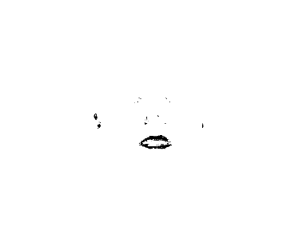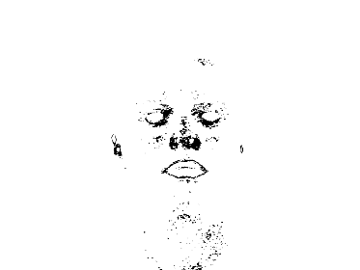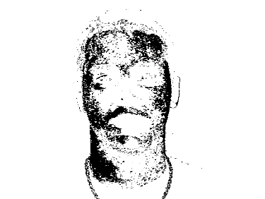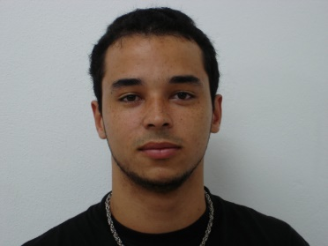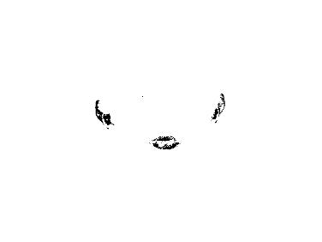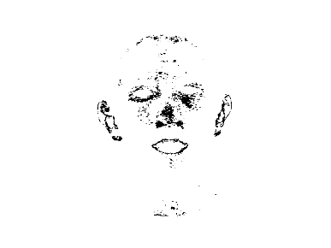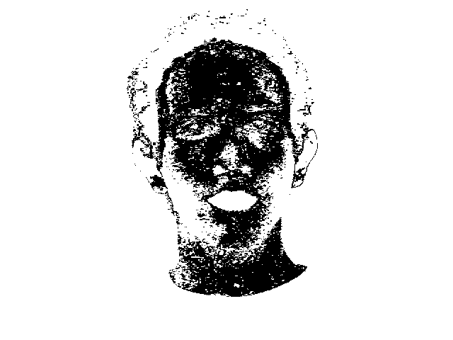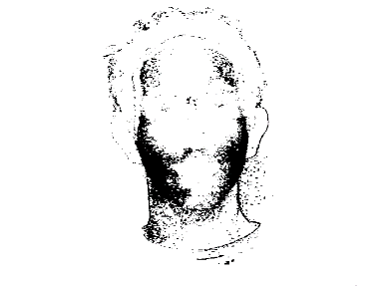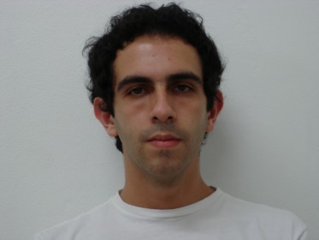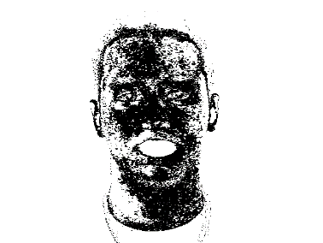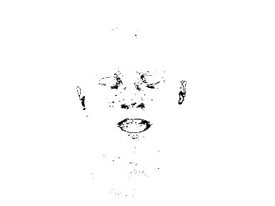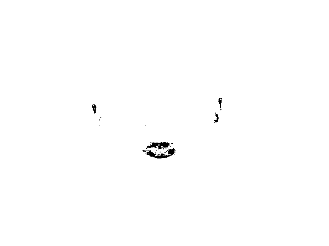**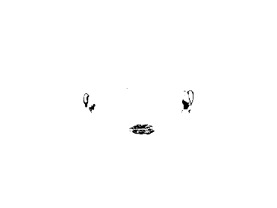***Find the images of x_11.jpg format from the given set that exhibit the Standard Behavior.*

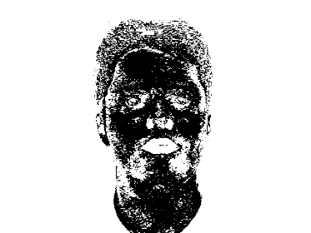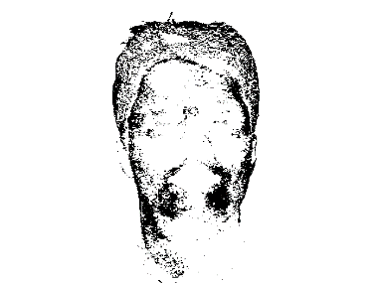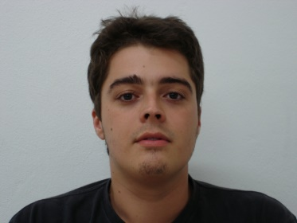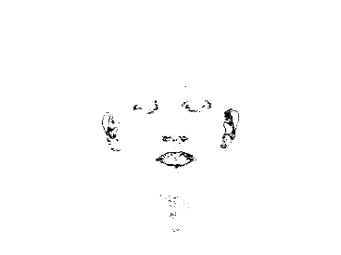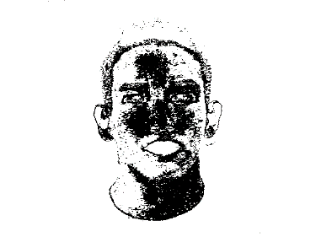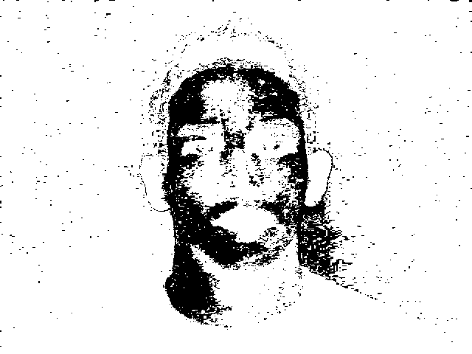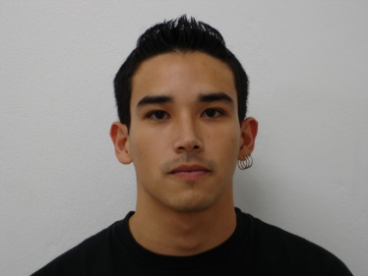

All the images from the set exhibit the Standard Behavior.

* 1. *Apply different filters before and/or after the extraction of the Binary Layers and report the results.*

1. ***A picture containing sky, outdoor

   Description automatically generatedBinary_Layaer_0 for image 47_11.jpg***
2. Gaussian Blur Radii = 2. Binary_Layer_0.

1. Binary_Layer_0. Maximum Radii = 1.
2. A person posing for the camera

   Description automatically generatedBinary_Layer_0. Gaussian Blur Radii =1. Minimum Radii = 1. Median radii = 4.
3. Maximum Radii = 2.A close up of a mans face

   Description automatically generated Binary_Layer_0. Median Radii=3. Median Radii = 3. Maximum Radii = 3. Maximum Radii = 1, Minimum Radii = 2. (not optimal at all).
4. Gaussian Blur radii = 2. Binary_Layer_0. Maximum radii = 2. (almost the same result as above but less filters used)



1. Median radii=2. Median radii=2. Binary_Layer_0. Gaussian Blur radii = 3. Mean radii=5. Minimum radii=1.
2. Maximum radii = 2. Binary_layer_0. Minimum radii=1. Gaussian blur radii=2. Maximum radii = 3.
3. 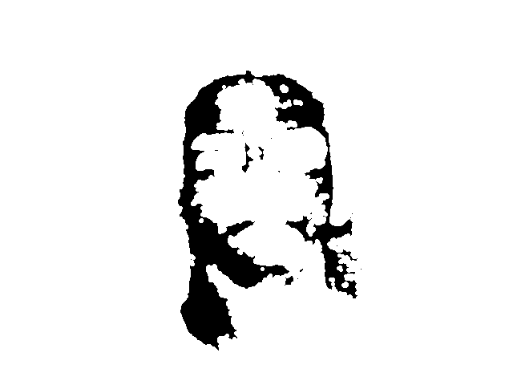Median radii=2. Gaussian Blur radii=1. Binary_layer_0. Maximum radii=1. Maximum radii=0.5.
4. ***Binary_Layer_1 for image 47_11.jpg***



1. Gaussian Blur Radii = 2. Binary_Layer_1.
2. Gaussian Blur Radii = 2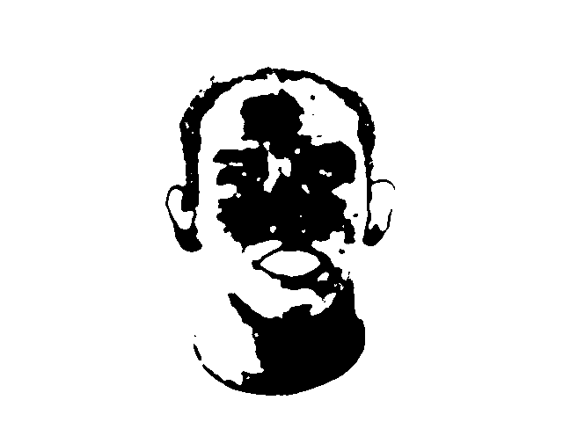. Binary_Layer_1. Median radii= 2.
3. Gaussian Blur radii = 2A close up of a logo

   Description automatically generated. Binary_Layer_1. Maximum radii = 2.

1. Binary_Layer_1. Gaussian Blur Radii =1. Minimum Radii = 1. Median radii = 4.
2. Maximum radii = 2. Binary_layer_1. Minimum radii=1. Gaussian blur radii=2. Maximum radii = 3.



1. Median radii=2A close up of a mans face

   Description automatically generated. Gaussian Blur radii=1. Binary_Layer_1. Maximum radii=1. Maximum radii=0.5.



1. Binary_Layer_1. Median radii=2. Median radii=3. Minimum radii =1.



1. Minimum radii=2. Binary_Layer_1. Median radii=3. Gaussian Blur radii=3. Minimum radii=1.
2. ***Binary_Layer_2 for image 47_11.jpg***
3. Gaussian Blur Radii = 2. Binary_Layer_2.



1. Gaussian Blur Radii = 2. Binary_Layer_2. Median radii = 2. (Not needed)

1. Minimum radii=1. Binary_Level_2. Median radii=1. Minimum radii=1.

1. Gaussian Blur radii = 2. Binary_Layer_2. Maximum radii = 2.

1. Binary_Layer_2. Gaussian Blur Radii =1. Minimum Radii = 1. Median radii = 4.

1. Binary_Layer_2. Median radii=2. Median radii=3. Minimum radii =1.

1. Minimum radii=2. Binary_Layer_2. Median radii=3. Gaussian Blur radii=3. Minimum radii=1.



1. Minimum radii = 1. Binary_Layer_2. Median radii=1, Gaussian Blur radii=1, Minimum radii=1.



1. ***Binary_Layer_3 for image 47_11.jpg***
2. Gaussian Blur Radii = 2. Binary_Layer_3.



1. Minimum radii=1.A close up of a person

   Description automatically generated Binary_Level_3. Median radii=1. Minimum radii=1.
2. A close up of a logo

   Description automatically generatedBinary_Layer_3. Gaussian Blur Radii =1. Minimum Radii = 1. Median radii = 4.
3. Minimum radii = 1. Binary_Layer_3. Median radii=1. Gaussian Blur radii=1. Minimum radii=1.

1. Binary_Layer_3. Median radii=0.3. Minimum radii=0.5.

1. Median radii=3. Minimum radii=1. Binary_Layer_3. Gaussian Blur radii = 1. Minimum radii = 1.

***To conclude the results for image 47_11.jpg,*** *only some of the 30 cases had positive result. To find the universal good combination of filters for this picture, all the good combinations of filters for each Binary_Layer should be considered, and the intersections of those sets should be chosen.*

1. Binary_Layer_0
2. Maximum Radii = 2. Binary_Layer_0. Median Radii=3. Median Radii = 3. Maximum Radii = 3. Maximum Radii = 1. Minimum Radii = 2. (not optimal at all).
3. Gaussian Blur radii = 2. Binary_Layer_0. Maximum radii = 2. (almost the same result as above but less filters used)
4. Median radii=2. Gaussian Blur radii=1. Binary_Layer_0. Maximum radii=1. Maximum radii=0.5.
5. Binary_Layer_0. Gaussian Blur Radii =1. Minimum Radii = 1. Median radii = 4.
6. Binary_Layer_1
7. Gaussian Blur Radii = 2. Binary_Layer_1. Median Radii = 2.
8. Binary_Layer_1. Gaussian Blur Radii =1. Minimum Radii = 1. Median radii = 4.
9. Binary_Layer_1. Median radii=2. Median radii=3. Minimum radii =1.
10. Binary_Layer_3
11. Minimum radii=1. Binary_Level_2. Median radii=1. Minimum radii=1.
12. Binary_Layer_2. Gaussian Blur Radii =1. Minimum Radii = 1. Median radii = 4.
13. Minimum radii = 1. Binary_Layer_2. Median radii=1. Gaussian Blur radii=1. Minimum radii=1.
14. Binary_Layer_3
15. Gaussian Blur Radii = 2. Binary_Layer_3.
16. Binary_Layer_3. Gaussian Blur Radii =1. Minimum Radii = 1. Median radii = 4.
17. Median radii=3. Minimum radii=1. Binary_Layer_3. Gaussian Blur radii = 1. Minimum radii = 1.

So, the combination of filters that works best for this images with each layer is:

Binary_Layer_0. Gaussian Blur Radii =1. Minimum Radii = 1. Median radii = 4.

To be continued.